PROJECT REPORT TEMPLATE

**1 OVERVIEW**

1.1INTRODUCTION:

The title of the project allotted to our group is CRM (Customer Relationship Management) application that helps to book VISA slot. A visa slot management project is a system that is used to track and manage the availability of visa slots, which are appointments that are required for certain visa applications.

1.2PURPOSE:

CRM based application has variety of applications and particularly it is used by a

government agency or a visa processing centre to schedule and manage appointments with applicants.   
**2 PROBLEM DEFINING AND DESIGN THINKING**

2.1 Empathy map

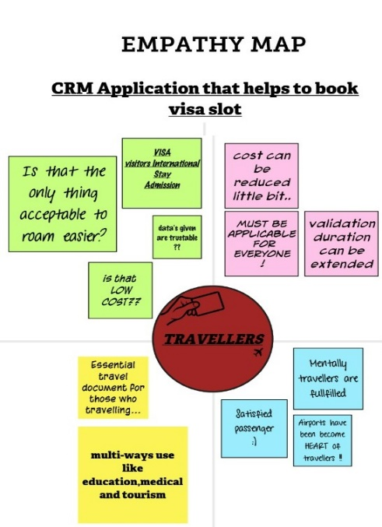

2.2 Ideation and Brainstorming map

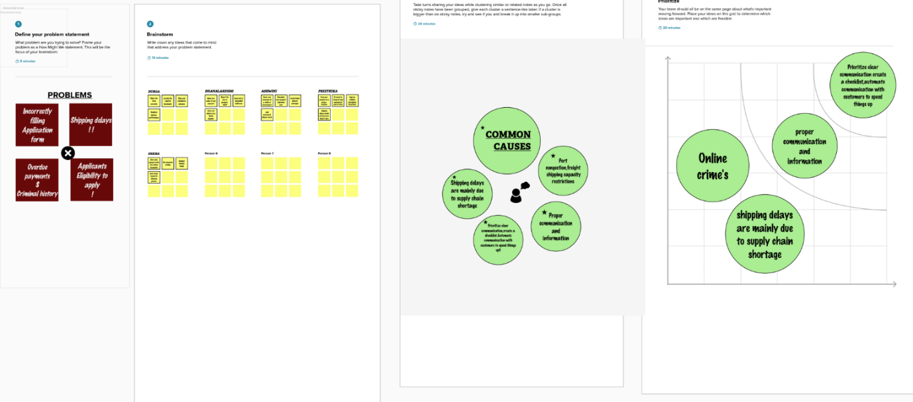

**3 Result**

3.1 Data Model:

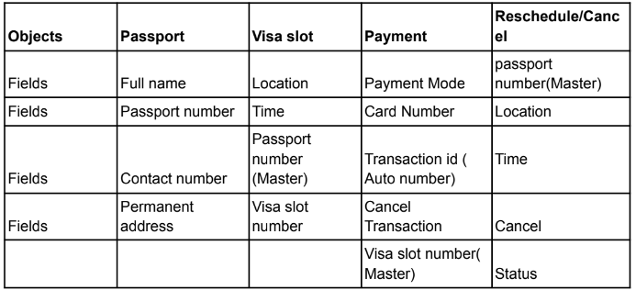

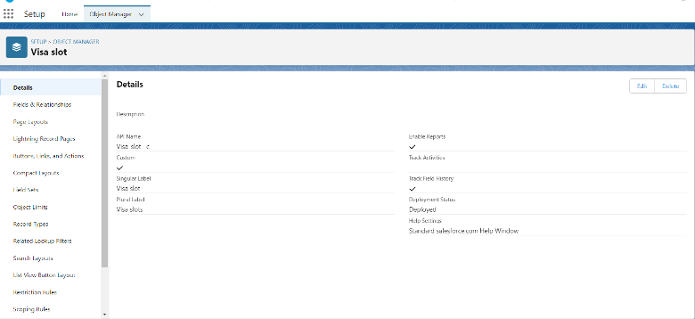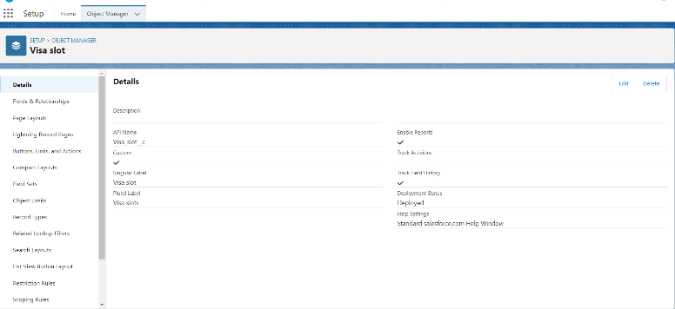

**3.2 Activity and screenshot:**

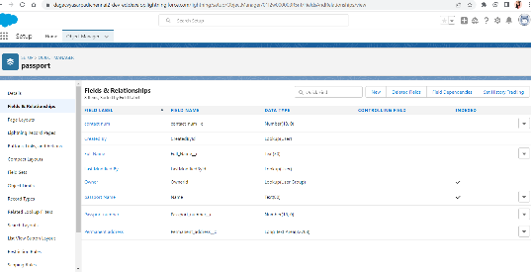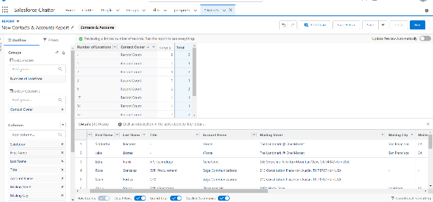

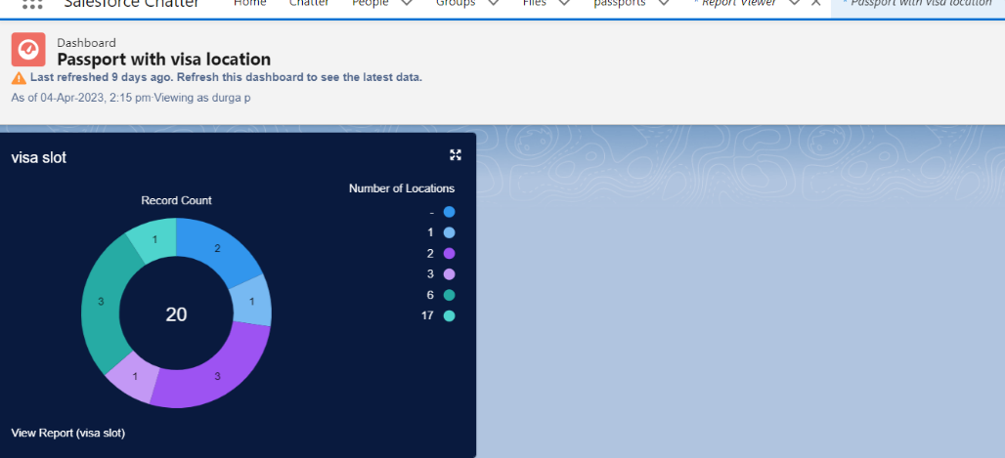

**4 Trailhead profile public URL:**

Team Lead : <https://trailblazer.me/id/durga3018p>

Team Member1: <https://trailblazer.me/id/snehaasi>

Team Member2: <http://trailblazer.me/id/ashwini8>

Team Member3:

Team Member4: <http://trailblazer.me/id/dhana17>

**5 Advantages and Disadvantages:**

|  |  |
| --- | --- |
| **Won’t have to fill out lengthy visa application forms to gain entry.** | **Unprotected chips are subject to clandestine scanning.** |
| **Visa-free access to 60 countries in Asia.** | **Main Problem is, there is No Extension.** |
| **Passport is a formal government-issued ID.** | **Shorter initial stay.** |
| **Some visa give you more freedom than others.** | **Labour condition application requirement.** |
| **To qualify for a visa, passport is actually needed.** | **Traveller purpose id not permitted on Visitor Visa.** |

**6 Applications:**

* **Ordinary Passport** (Dark Blue cover) is issued to ordinary citizens for private travel, such as for vacation, study and business trips. It is a "Type P" passport, where *P* stands for *Personal*.
* **Official Passport** (White cover) is issued to individuals representing the Government of India on official business, including members of the [Indian Armed Forces](https://en.wikipedia.org/wiki/Indian_Armed_Forces) stationed abroad. It is a "Type S" passport, *S* stands for *Service.*
* **Diplomatic Passport** (Maroon cover) is issued to Indian diplomats, [Members of Parliament](https://en.wikipedia.org/wiki/Member_of_parliament_(India)), [members of the Union Council of Ministers](https://en.wikipedia.org/wiki/Union_Council_of_Ministers), certain high-ranking government officials and diplomatic couriers, as well as their dependants. Upon request, it may also be issued to high-ranking state-level officials travelling on official business. It is a "Type D" passport, with *D* standing for *Diplomatic*.

**7 Conclusion:**

A visa slot management project is a system that is used to track and manage the availability of visa slots, which are appointments that are required for certain visa applications. It might be used by a government agency or a visa processing centre to schedule and manage appointments with applicants.

**8 Future Scope:**

***The method for submitting an application for a fresh passport will remain the same, as will travel insurance. The Ministry of External Affairs plans to provide electronic passports to all 36 Indian passport offices. The issuing method will remain unchanged. Over 120 countries, including the United Kingdom, the United States, and Germany, have previously accepted the e-passport model, which includes the biometric e-passport infrastructure.***

***To transition away from printed documents, the government will start distributing e-passports this year, all equipped with integrated electronic chips. Although the procedure will not be completely paperless because services like visa stamping will still exist, it will considerably reduce the need for paperwork by automating the process as much as feasible.***

***The introduction of e-passports with integrated chips is a positive step for the Indian travel and tourism sector since it will make international travel easier, allowing more individuals to travel abroad. This would increase the influx of international tourists making the country a top choice for international vacation spots for people around the world. The move will also enhance security, first and foremost, because it would be difficult for criminals to forge or steal an e-passport.***